Testing Document

### Story 05: The ability to log in as a current user

Expected result:

* The user will be able to see the log in link on the landing page.
* The user who has a current account will be able to fill in their username and password to log in to the application.
* 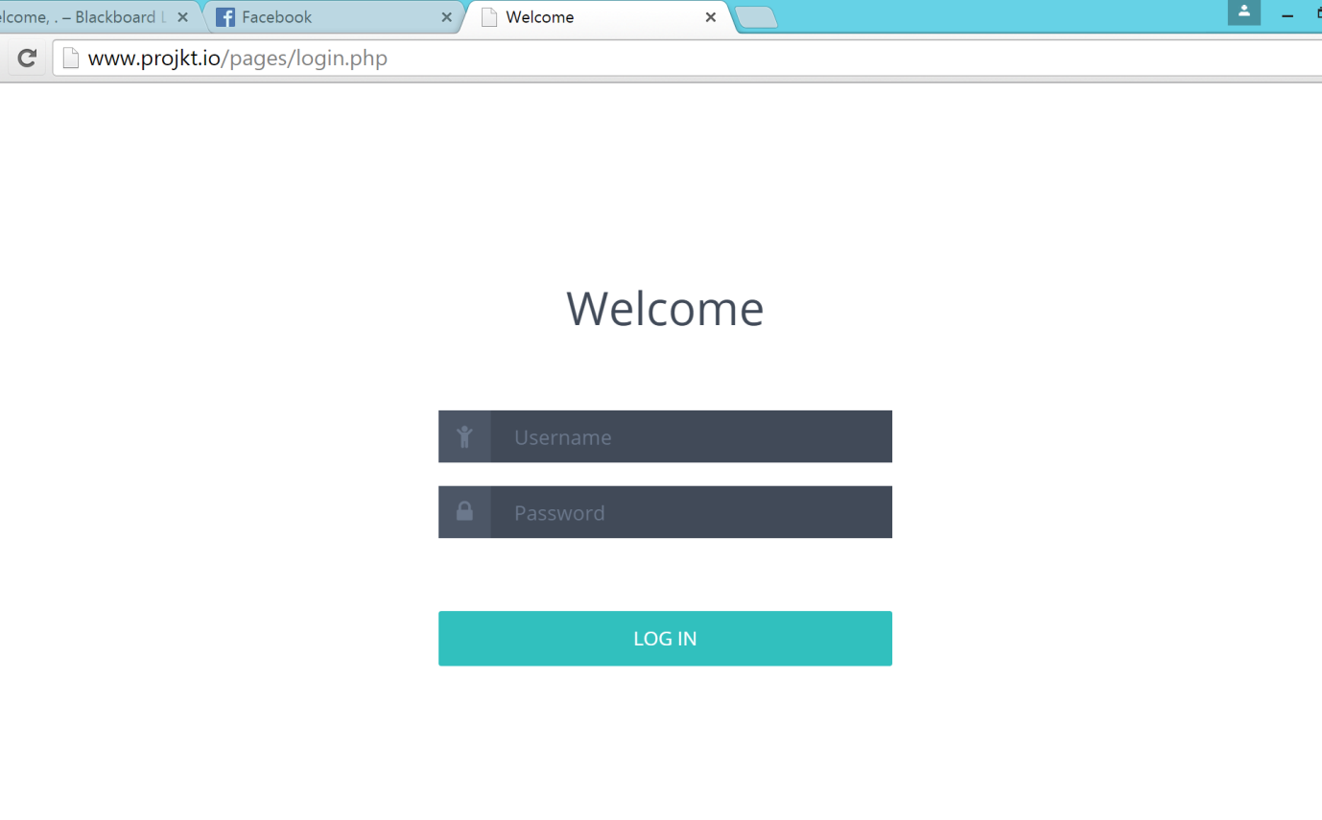The user who has not entered the correct username or password, the error message will be popped up and prompt the user to re-enter the username and password.

# Result:

The results have met the acceptance criteria listed above.

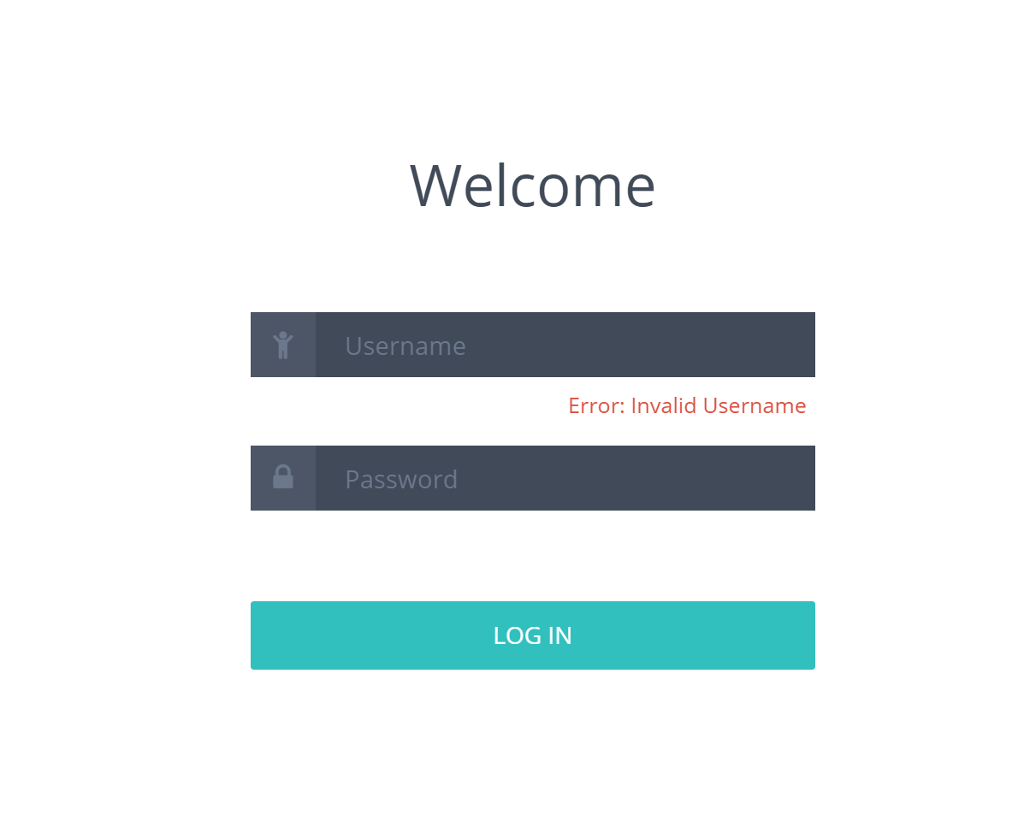

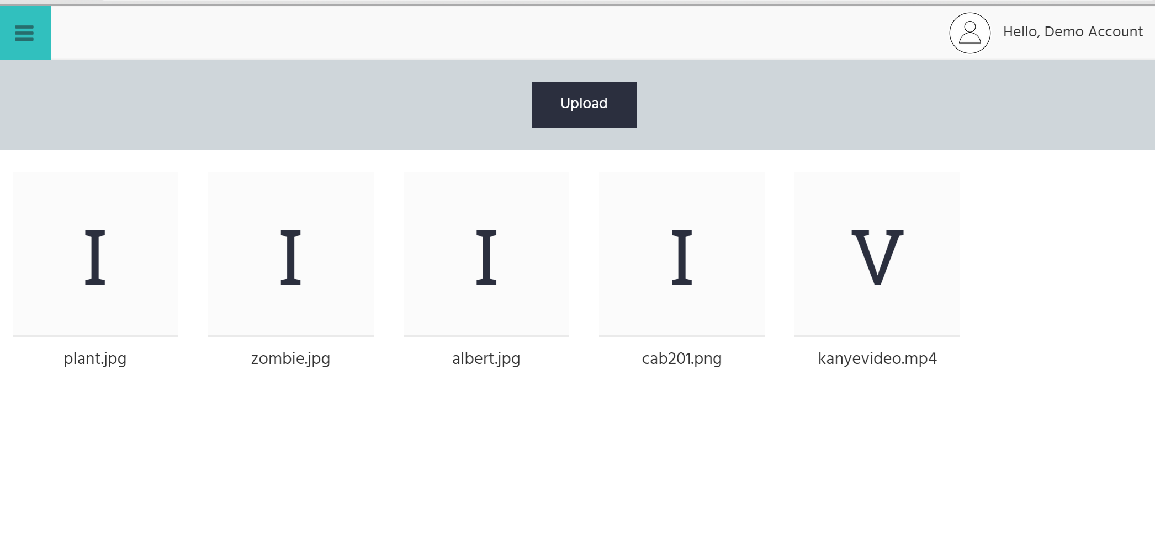

### Tool used to conduct testing: Ghost Inspector

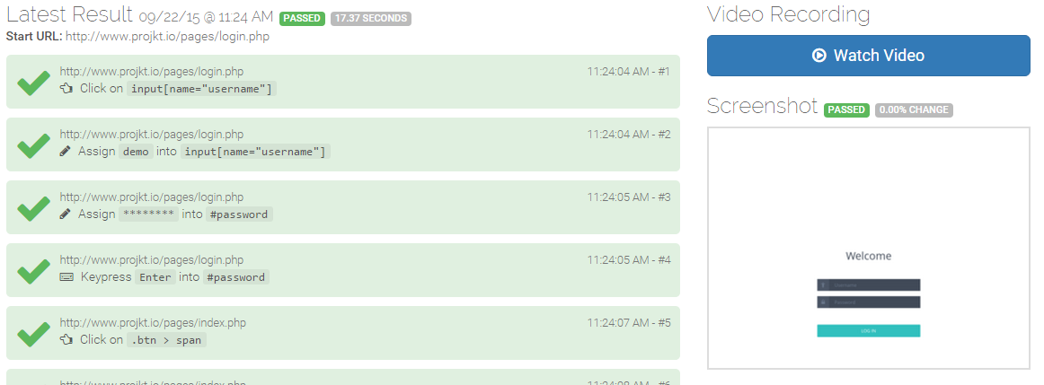

### Story 016: The ability to log out as a logged in user

Expected result:

* The currently logged in user will be able to log out of the application by using the **‘Logout’** link on the page.

# Result:

The results have met the acceptance criteria listed above.

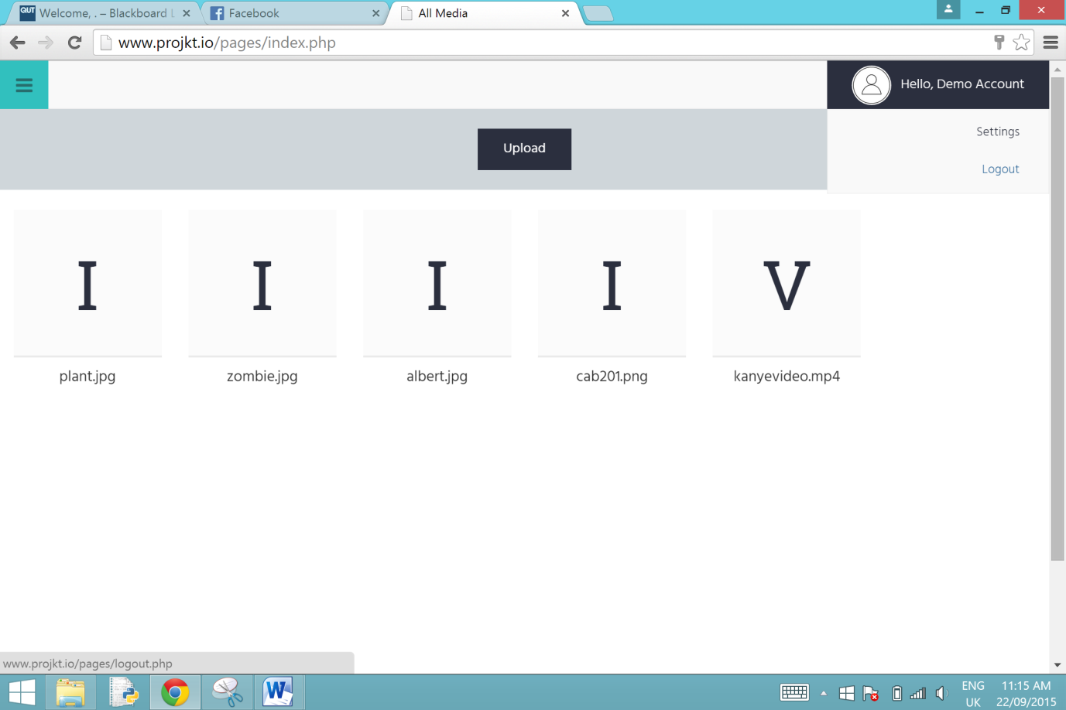

### Tool used to conduct testing: Ghost Inspector

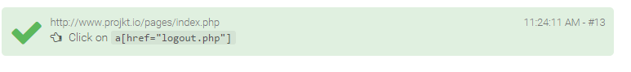

### Story 07: The ability to sign up as a new user

Expected result:

* The new users should be able to sign up their new accounts using the ‘Sign up form’ on the application.

# Result:

The results have met the acceptance criteria listed above.

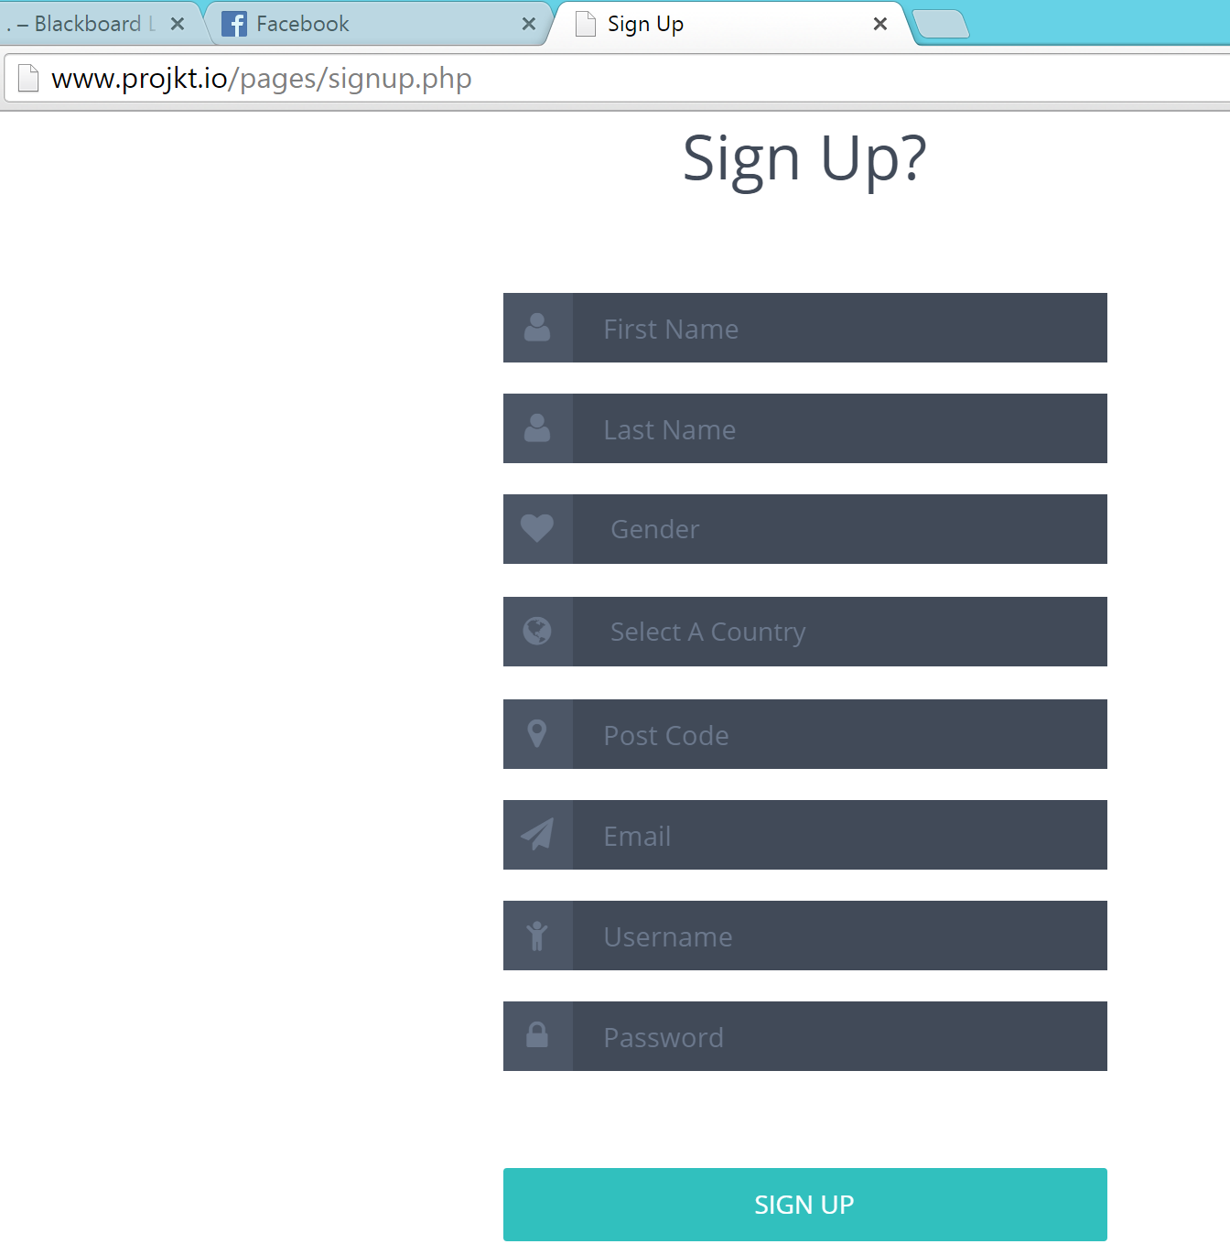

### Tool used to conduct testing: Ghost Inspector

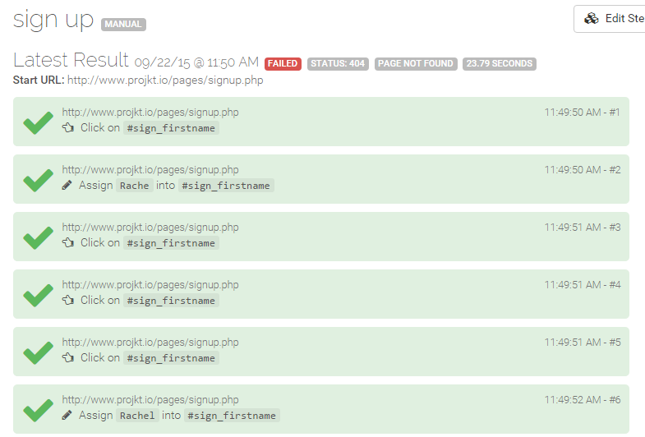

### Story 08: The ability to upload media

Expected result:

* The logged in user will be able to upload their media to the account.
* The user will be able to upload the items by browsing their devices.

# Result:

The results have met the acceptance criteria listed above.

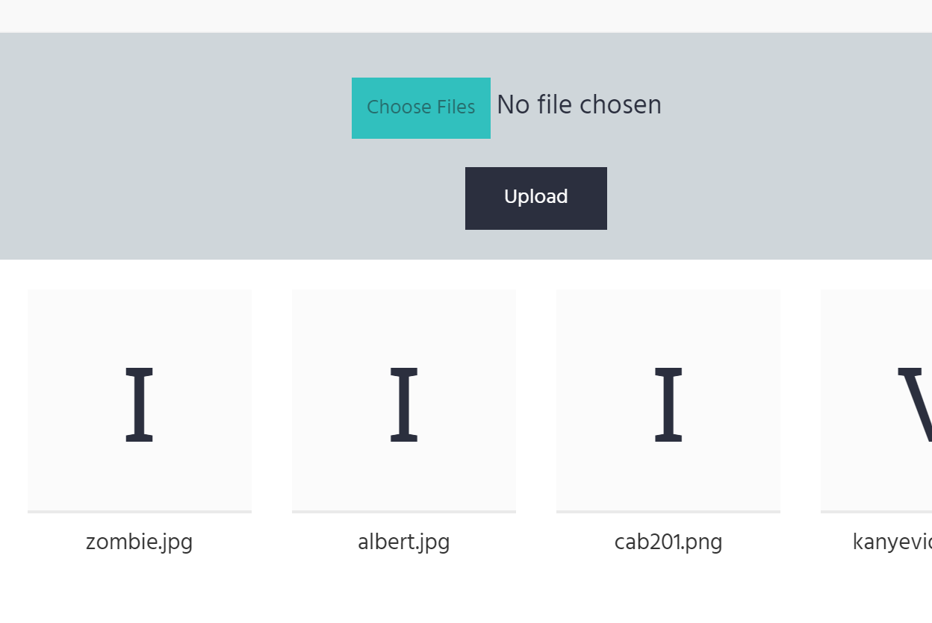

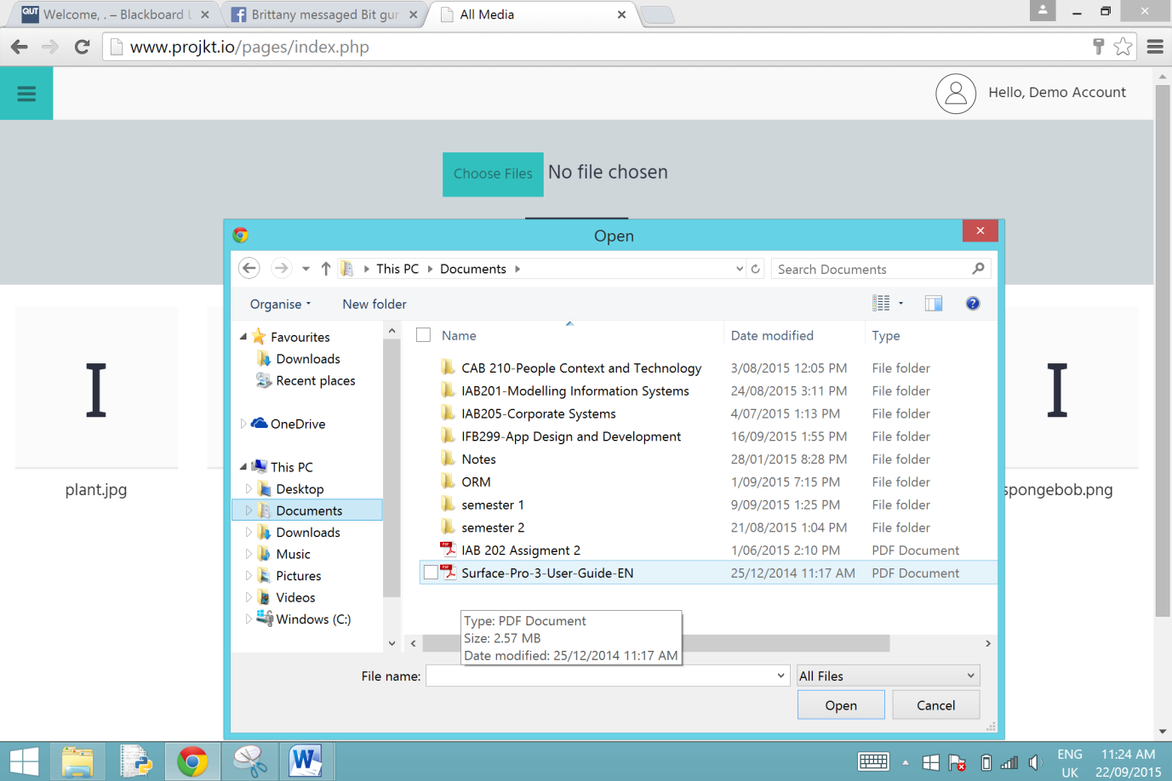

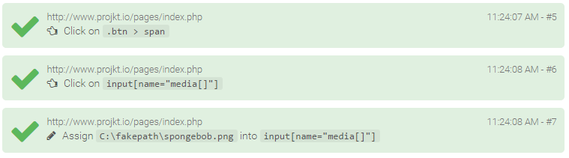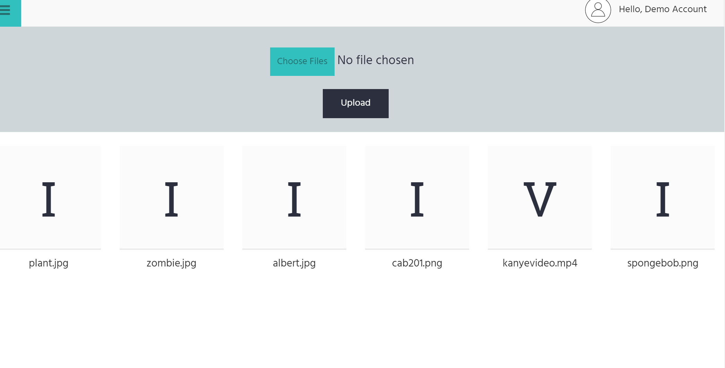

### Story 09: The ability to download media

Expected result:

* The logged in user will be able to upload their media to the account.
* The user will be able to upload the items by browsing their devices.

# Result:

The results have met the acceptance criteria listed above.

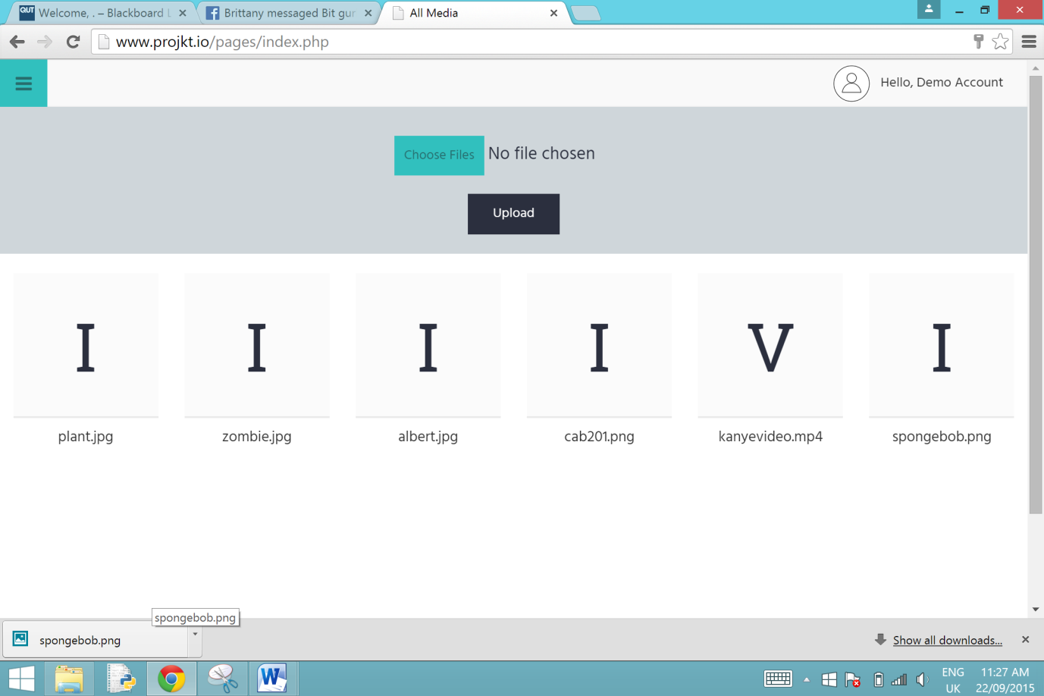

### 

### Story 017: The ability to view the general media library on the home page

* The users will be able to view their uploaded media on the home page.

# Result:

The results have met the acceptance criteria listed above.

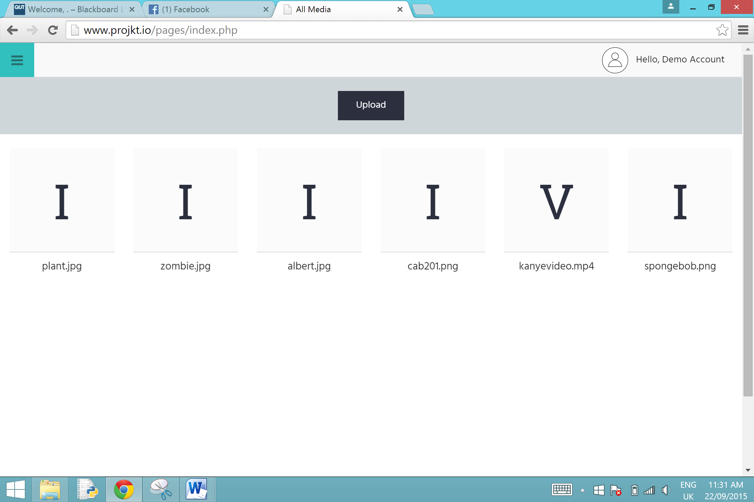

### Tool used to conduct testing: Ghost Inspector

